Amadeus Chorale Handbook for Singers and their Families

The motto of the Amadeus Chorale is
“Life Lessons through Singing”

Amadeus Chorale History – how did we get here?
Several years ago, Miss Darla was teaching Music to 4th and 5th graders in the Brockport, New York school district, which is on the west side of Rochester. There was a children’s choral program on the other side of the city, and several of her children auditioned and were accepted each year. When parents began to complain about spending every Saturday morning ‘way across town,’ Miss Darla’s brain lit up. Her own daughter had been selected to sing in a children’s chorus at Carnegie Hall with director Henry Leck two years earlier and Miss Darla had lunch with director Dr. Leck to pick his brain about his multi-level Indianapolis Children’s Chorus program. When she returned to Brockport, she gathered a few parents who had shown an interest in an out-of-school choral program for talented children on the west side of Rochester, and the Amadeus Chorale was born in 1996.
A Board of Directors was formed, the organization gained 501(c)3 non-profit status, and a collaborative pianist was hired. Touring, recording, concertizing, collaborating with orchestras and other musicians turned into twenty-five years of wonderful music-making for thousands of children.
In February, 2026, the Lancaster, PA, site of the Amadeus Chorale will be born!

What singers need to do
Singers and a parent or guardian must attend an initial information meeting where Miss Darla will conduct informal auditions. The child will sing “Happy Birthday” with Miss Darla and then echo back some simple tones and phrases. Miss Darla will either recommend joining the Amadeus Chorale right away or suggest a few voice coaching sessions before joining.
After singers join the chorus, they are expected to follow the guidelines of what is called “The Amadeus Way.”

The “Amadeus Way”
If there is a right way to do something, Amadeus does it the right way. This includes singing, manners, how to hold folders, how to dress for performances and how to take attendance on the tour bus!
Singers are artists, and Amadeus celebrates their diversity! No matter how a singer physically presents, The Amadeus Way requires that they behave respectfully and kindly to everyone involved – directors, other singers, all adults. Singers are required to display responsibility at rehearsals, in performances and on tours.
Electronic devices are turned off for rehearsals. Of course, when rehearsal is finished, singers may connect with their rides home. Electronic devices are left at home or with parents for performances.
For performance, hair is worn off the face, so the audience can see all facial expressions that accompany our music. If hair is long enough, French braids are required for performances.
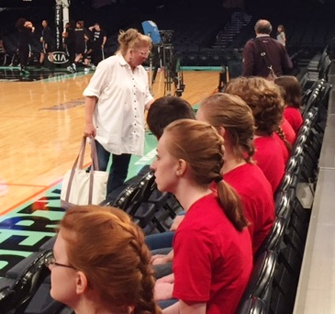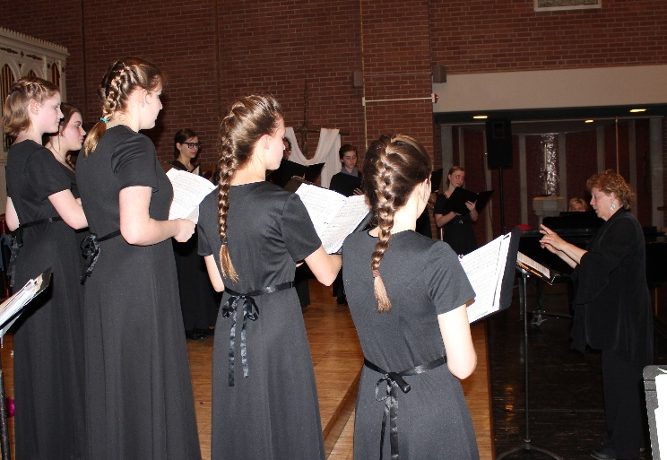

Performance outfits for each choir:
SaraSingers (ages 6-10)
- White tuxedo shirt with black stud buttons, black dress pants, black socks, black shoes. Red bowties
Lyric Choir (ages 11-14)
- White tuxedo shirt with black stud buttons, black dress pants, black socks, black shoes, Black bowties. Black, sparkly vests OR
- Black dresses black stockings, black shoes
When we travel, a navy polo will be issued to each singer, to be worn with jeans. Singers will also be given a complimentary tour shirt specific to that trip. It will also be worn with jeans. These shirts, in addition to our red, signature t-shirts will constitute our wardrobe for touring.

Attendance
Attendance will be taken at every rehearsal, with the expectation that all singers commit to all rehearsals and performances when they join the Amadeus Chorale. If a singer knows they will miss a rehearsal, they are asked to send a text or email to the office. If singers miss two rehearsals without notifying the director or office, they may be asked to attend a special make-up rehearsal to assure they know their music.
Missing a performance is permitted only if the singer is ill. Please plan family excursions and singer’s other activities, so singers can attend every performance. Our calendar is sent to families in a timely manner, so you can plan ahead.

Expectations at rehearsals
Singers are expected to arrive at rehearsals a bit early, so we can begin rehearsing at exactly the right time. Since the Amadeus Way respects time management, singers will be released from rehearsal at the stated time, as well.
Each singer should have a water bottle and their music folder at every rehearsal. A sharpened or mechanical pencil should be inside the music folder.

Music Folders
Singers will be given a music folder complete with the pieces they need for the semester. The music folder must be brought to every rehearsal. If a music folder is lost or returned with incomplete music, a $20 charge will be made to the family.

ASL – American Sign Language
Each concert, the singers will perform a piece with ASL signs for some of the vocabulary. We do not teach ASL, with its syntax and unique sentence structure; we teach vocabulary words that may inspire a singer to further their own education in American Sign Language.
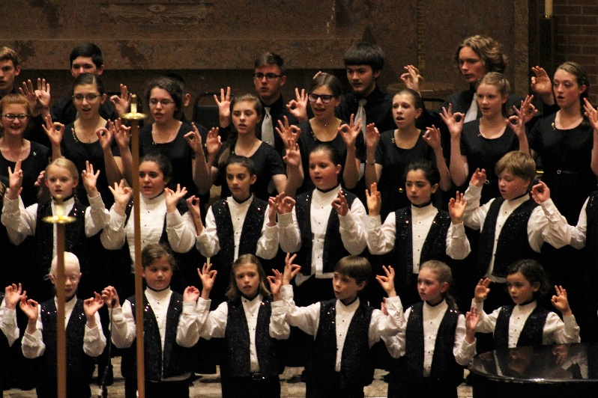
Expectations for Performances
On performance days, singers are expected to be ready to sing – hair done, wardrobe perfect and standing in the right place – at 5:59 for a 7:00 pm concert. Parents will remain in the lobby until the doors open at 6:35 pm. Our Choir Moms will handle unexpected emergencies of bobby pins, band-aids and extra socks.
Summer Camp
Each summer, a three-day camp will be offered for all singers. There will be a $75 fee for the three days. Singers’ friends who are not in Amadeus may join us for camp. Camp registration forms will be available each spring.

Fundraisers
There will be opportunities for singers to raise funds for tuition, touring and wardrobe items. There may be a fundraiser that is for the good of the organization instead of for individual singers. Parents are expected to volunteer to plan and carry out the fund raisers with the direction of our Fundraising Chairperson.

Touring
Singing outside the Lancaster area is an integral part of the Amadeus Chorale Youth Singers curriculum. Our first trip will be to New York City to sing at Radio City to open for the Rockettes Christmas Spectacular in November, 2026.


Recording
Our singers will experience the joy and the hard work of recording. We may record on site or in studio, depending on the pieces we are working on.

Social Media, Emails, Instagram, Radio, TV, Newspapers
If we need to cancel a rehearsal for any reason, the cancellation will be announced to families by way of email. It will also be posted on our website, www.theamadeuschorale.org
If we need to cancel a performance, we will post the cancellation on our Amadeus Chorale website and on local radio and tv stations.
Photographs and recordings of singers may appear on our Amadeus FaceBook page, Instagram account and in press releases to local newspapers, radio stations, television stations and sites promoting children’s activities. If you do not want your singer to be on social media, please ask for our Opt Out form.
Once a year, performance outfits will be worn to rehearsal, so a group photo can be taken.

Tuition and Fees
Tuition for the Spring term of 2026 is $175 for each singer. Yearly tuition will begin Fall, 2026 at $350 for each singer. Tuition covers high-level Music Education, printed music, music folders, fees for accompanists, and rental of rehearsal/performance spaces.
In addition to tuition, each singer will purchase performance wardrobe items. Families will be given clear instructions on ordering wardrobe items.

School Programs and Participation
The Amadeus Chorale works hand in hand with teachers in public and private schools. In that light, Amadeus strongly encourages our singers to be leaders in their school programs. If there is a conflict with scheduling, please let Miss Darla know, and we will make a plan that supports the singer.

Our Literature
The Amadeus Chorale repertoire includes music that is age-appropriate for each choir, both in text and in musicality. When we sing a piece from a culture or religion that does not represent your singer, please remember that we are not promoting a particular religion, language or culture. We are a teaching chorus and want to expose our singers to a wide range of global music.

Board of Directors, Board of Advisors
The Amadeus Chorale’s fiscal health is overseen by a Board of Directors who meet quarterly. The Board of Advisors is a committee of parents and other community members who want to have hands-on experience in the operations of the Chorale. They meet monthly (except for July, August, and December) and are the backbone of strength in the organization. Should you want to join one of these Boards, please contact our office musictohealourworld@gmail.com or 585.494.1795.
After serving on the Board of Advisors for three years, the Board member’s child receives free tuition for all consecutive years.

Yearly Pins
After singing in the Amadeus Chorale for three years, a singer is awarded a gorgeous red gemstone pin to be worn on all performance clothing from then on. Each year afterwards, a new pin (new color) is given to the singer. Singers wear all their pins in a cascade on the rim of the neckline or on their collars. Collecting these pins is a visual indication of the commitment our singers make to this organization. The photo is singer Kate McAuliffe (who ended up being an 11-year singers!) pinning the yearly pin on a younger singer, Ryleigh Weader.

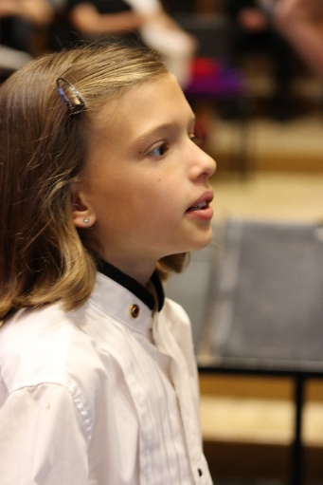
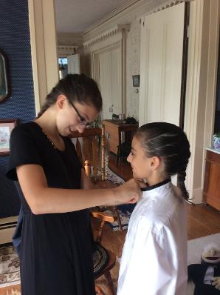
Young singer wearing her first pin.
Legal Matters
The Amadeus Chorale, Inc. is a non-profit 501(c)3 organization, with a Board of Directors.

Reviewed 11.5.25

